Library Seating Reservation System

——**Report part one and part two**

Team leader: William

Member: Alan Scott Andy Abbot Mike

1. Customer Problem Statement ----------------------------------------------------------------- 1

1.a Problem Statement ---------------------------------------------------------------------------- 3

1.b Glossary of Terms ----------------------------------------------------------------------------- 4

2. System Requirements -------------------------------------------------------------------------- 6

2.a Enumerated Functional Requirements -------------------------------------------------- 8

2.b Enumerated Nonfunctional Requirements --------------------------------------------- 9

2.c User Interface Requirements ------------------------------------------------------------- 10

3. Functional Requirements Specification ----------------------------------------------------- 14

3.a Stakeholders -------------------------------------------------------------------------------- 14

3.b Actors and Goals --------------------------------------------------------------------------- 14

3.c Use Cases ------------------------------------------------------------------------------------ 15

3.d System Sequence Diagrams -------------------------------------------------------------- 17

4. User Interface Specification ------------------------------------------------------------------ 23

4.a Preliminary Design ------------------------------------------------------------------------ 23

4.b User Effort Estimation -------------------------------------------------------------------- 25

Work breakdown form——Report one-part one

|  |  |  |  |  |  |  |  |
| --- | --- | --- | --- | --- | --- | --- | --- |
|  | | Open Fire | | | | | |
| Responsibility  levels |  | William | Scott | Andy | Mike | Abbot | Alan |
| Problem Statement |  |  | 50% |  |  | 50% |
| System Requirements | 50% |  |  |  |  | 50% |
| Enumerated Functional Requirements |  |  |  |  | 100% |  |
| Enumerated Nonfunctional Requirements | 40% | 60% |  |  |  |  |
| User Interface Requirements | 20% |  |  | 80% |  |  |

Work breakdown form——Report one-part two

|  |  |  |  |  |  |  |  |
| --- | --- | --- | --- | --- | --- | --- | --- |
|  | | Open Fire | | | | | |
| Responsibility  levels |  | William | Scott | Andy | Mike | Abbot | Alan |
| Stakeholders |  | 50% |  | 50% |  |  |
| Actors and Goals |  |  |  | 50% | 50% |  |
| Use Cases | UC2  UC3 | UC6 | UC7 | UC4 | UC5 | UC1 |
| System Sequence Diagrams | 50% |  |  |  |  | 50% |
| Preliminary Design |  |  | 50% |  |  | 50% |
| User Effort Estimation |  | 50% | 50% |  |  |  |

Library Seating Reservation System Project Report#1

1. Customer Problem Statement

1.1 Problem Statement

The library is a public place where documents are collected and organized and students are provided to study. It is an important resource for university study. Learning and making full use of the library's academic resources is the basic skill that every college student must master. However, as a librarian, I found that many study seats are only books, no one. Many students just put school supplies on the table, no one is sitting, causing students to complain to the library many times about the seat.0 And such a situation will have a very bad impact. First of all, such a situation will affect student learning. Students who want to study can't study hard without sitting. Second, such a situation will affect the order of the library. There are items in the seat but no one is wasting resources. In the end, such a situation will hurt the reputation of the library and will make everyone feel that library management is not working.

The above problems all reflect the problems of our library and cannot be delayed for too long. As a librarian, we are very pleased with the enthusiasm of students for learning. Because students love to learn, especially for students who want to take a postgraduate degree, seat is to avoid the way they can not find a seat. Even when the library opens, there are many students who go in and place their books to occupy seats. However, some of the occupied students took up the seat but did not return, causing other students to find no place to sit. This kind of behavior is selfish behavior. Students who can't find a seat are reflected in our librarians, which makes us very difficult. Therefore, in order to prevent this uncivilized behavior from happening and give students a better learning atmosphere and environment for the library, we have implemented some programs.

The first option, regional management. Each floor of the library is divided into several areas; each area is arranged for management. This kind of supervision program can effectively take care of the seats in each area. Once the occupants are found not to return, they can place their items in the custodial office and clean the table to the next person who needs to be used. However, this program requires a large number of people, so we decided to use the students as temporary workers to solve personnel problems. In the second program, the students of the postgraduate study arrange the study place independently. We found that many college students have plans for postgraduate study, so we believe that the students in the postgraduate study can be arranged in the library's self-study room to reduce the occupancy. For the above two scenarios, we try to simulate them.

The simulation results are not satisfactory. The problem with the first solution is the relationship between cost and students. In terms of cost, there are a large number of student workers, so more money is needed for them. And these student workers can also use their rights to take seats for others, which is out of our minds. The problem with the second option is that there is no substantial change. During the appointment of the postgraduate study room seating activity, the number of appointments exceeded the number of seats we expected. After we determined that the line was full, there were still a lot of students stranded. This is beyond our imagination and is also pleased with the learning power of today's college students.

The failure summary of the two programs prompted us to design a seat reservation system to solve the problem. The library seat reservation system is to allow students to be bound to the seat. When the student leaves the library, the seat is unlocked for use by the next classmate. In terms of cost, the price of our production system and machine is lower than the labor cost of the first solution. Moreover, the machine will only provide seats for students who enter the library and swipe their cards, and there will be no problem of inequality in distribution. We also advocate that the postgraduate study room coexists with this system, which not only solves the problem of too many students, but also can reasonably allocate the seats of the library. This is the library seating reservation system we need.

With the creation of the seat reservation system, the library's seating resources can be utilized. If the student wants a seat, he or she must choose a seat in the selection machine and can only carry the student card to complete. The student information is then bound to the seat for a limited period of time. In other words, this seat is the student's lifetime. This will prevent students from sitting in the seat. During the use of the seat by the student, if someone finds something else in the seat, the item can be carried to other public areas and the item must be completed. If the student finds someone else sitting in the seat, they need to declare that they have reserved the seat and asked the occupant to leave. If the occupant does not agree, he can ask for help from a nearby service person. The system can well meet the personal preferences of the majority of students, they can choose their favorite location. It is convenient and fast, and it can reflect the humanized service of the library. The seat reservation system then has precise management of the library's seats. The administrator can view the seat information at any time and record the flow of people on the day to facilitate finding and meeting the work needs. Finally, in the case of a large number of people, it can avoid the situation of random seating. Because students who need a seat must go to the landline to make a seat reservation

1. System Requirements.

Students can use the seat management system to find spare seats on the touch screen to lock the seat and release the seat when they leave. The login is done by swiping the campus card.

The main application of the program has the following characteristics: 1. Open the inquiry service for students, students can query, lock and release the seat through the touch screen; 2. Get the entry and exit information of the students through the touch screen terminal. The system automatically completes the user's seat lock and release seat action based on this information;

1. Check the seat

Students can log in to the seat management system to check if there are available seats through any touch screen terminal connected to the campus network. The system provides two ways to query, one is to query according to the classroom seating layout, and the other is to customize the filtering method. Can meet the different needs of students

2. Lock the seat

When there are still seats available in the venue, students can choose between quick match (automatic system assignment) or self-selection (manual selection) of the seat. After the seat is successfully determined, the system will provide an electronic voucher to completely solve the seat problem through the "voucher" method.

The voucher can be printed on the touch screen or taken with a mobile phone.

3. Cancel the seat

If you need to cancel your seat, you can check the record in ‘My Seat’ and cancel it within the specified time. The administrator can change the number of cancellations and how long before they can be cancelled.

4. Release the seat

When the student ends using the seat, leave the library to automatically release the seat

Management system

The administrator can set various data of the system through the management system, and can store and delete seat information.

User system

Users can achieve the following functions through the system:

1 check the seat;

2. Lock the seat;

3. Cancel the seat;

4. Release the seat.

2.1Enumerated Functional Requirements

Students can use the seat management system to find spare seats on the touch screen to lock the seat and release the seat when they leave. The login is done by swiping the campus card.

The main application of the program has the following characteristics: 1. Open the inquiry service for students, students can query, lock and release the seat through the touch screen; 2. Get the entry and exit information of the students through the touch screen terminal. The system automatically completes the user's seat lock and release seat action based on this information;

1. Check the seat

Students can log in to the seat management system to check if there are available seats through any touch screen terminal connected to the campus network. The system provides two ways to query, one is to query according to the classroom seating layout, and the other is to customize the filtering method. Can meet the different needs of students

2. Lock the seat

When there are still seats available in the venue, students can choose between quick match (automatic system assignment) or self-selection (manual selection) of the seat. After the seat is successfully determined, the system will provide an electronic voucher to completely solve the seat problem through the "voucher" method.

The voucher can be printed on the touch screen or taken with a mobile phone.

3. Cancel the seat

If you need to cancel your seat, you can check the record in ‘My Seat’ and cancel it within the specified time. The administrator can change the number of cancellations and how long before they can be cancelled.

4. Release the seat

When the student ends using the seat, leave the library to automatically release the seat

Management system

The administrator can set various data of the system through the management system, and can store and delete seat information.

User system

Users can achieve the following functions through the system:

1 check the seat;

2. Lock the seat;

3. Cancel the seat;

4. Release the seat.

2.2.Enumerated Nonfunctional Requirements

1. Easy to manage (reasonable allocation of seats, improve work efficiency)

2. Processing information fast

3. Saving labor

4. Information is not public

5. Applicable to other similar libraries

Many libraries do not have a reasonable system for assigning seats, which leads to students sitting in a mess. This system allows the library to have more seats available to accommodate more students. Most libraries require a lot of human resources to collect empty seats. The information is wasting a lot of unnecessary time. It can also be applied to places like libraries, such as restaurant ordering, bank queuing appointments. Some libraries' information is open to the public. People can check other people's information at any time. The information in this system is not public. Only those with sufficient authority can check private information (such as ID number, gender, age) and ensure that Information security. Many library systems process information very slowly, and users need to wait to get results. This system can process information quickly. If the information is correct, the user can quickly enter the software for use. Otherwise, the user will quickly get the information that he or she entered incorrectly.

2.3.User Interface Requirements

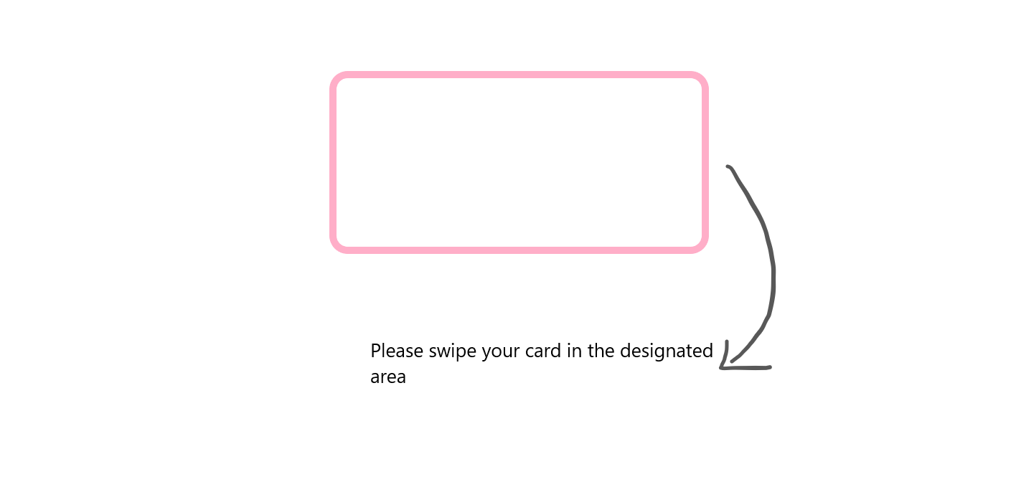

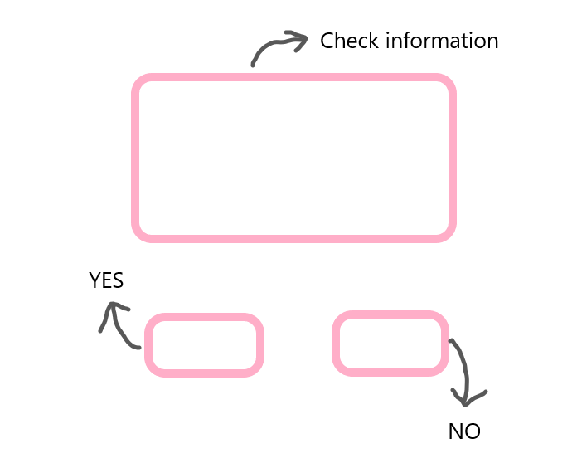

The above picture shows the student swiping the card, and the student can confirm the information on this page.

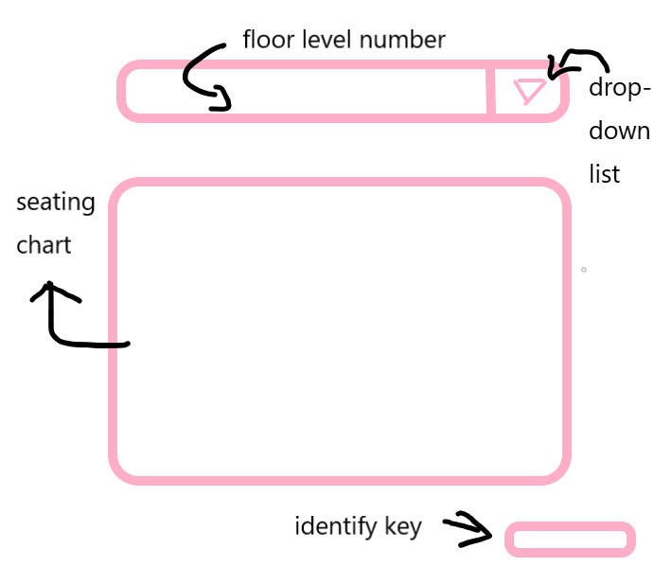

Students can see the number of library levels currently viewed in the top bar. The initial default is 1 floor. The inverted triangle on the right side can be popped up with a drop-down box. You can select the floor, the lower part is the library seat display, and the lower right corner is the confirmation button. After selecting the seat, the student clicks the button to submit the data. If the background shows that someone has selected the seat, a pop-up window will pop up to show that the seat has been selected, and after a few seconds, the page will automatically bounce back to the page again to select the page data. It will be refreshed based on the data in the database. If the selection is successful, the page will pop up and the selection will succeed. After a few seconds delay, it will automatically bounce back to the student landing page.

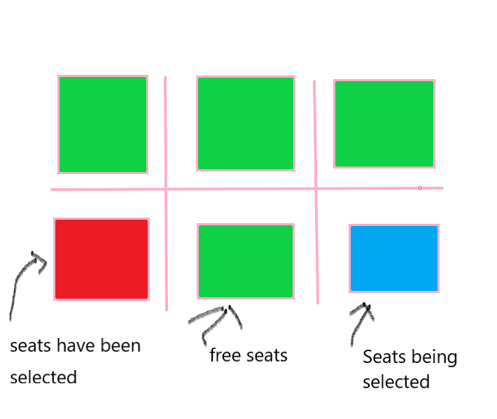

This is an example of selecting a seat page in the above picture. The seat that has been selected will display red, the free seat will display green, and when the green seat is selected by the user, it will display blue.

Library Seating Reservation System Project Report#2

Functional Requirements Specification

Stakeholders

●Users ○ Users can check the use of seats in a timely and convenient manner to prevent seats from being found.

●Librarian ○ Work on seat management, personnel management, and maintenance management

4.2 Actors and Goals

  ● User (initiated): ○ The user uses the username and password to perform online library selection activities on the platform.

● Database (participation): ○ Database provides data support for the system, enabling students to query library seating information

● Library login system (participation): ○ The library system will send student information to the system when the student leaves the library, so that the system can update the database in time.

Casual Description

The user enters the seat selection system, and the personal information is logged in through the background for review. After the login is successful, the database feedback seat information is selected and locked by the user, and the seat is released through the background when the user leaves. If the seat or other functions are damaged, a repair system is provided, and the user asks a question, which is processed by the background and then manually processed.

The administrator enters the system through the background login and is responsible for seat management management and warranty information processing. The addition and deletion are modified by calls between different data controls, and monitoring and feedback activities are performed in the background.

Use Case Diagram

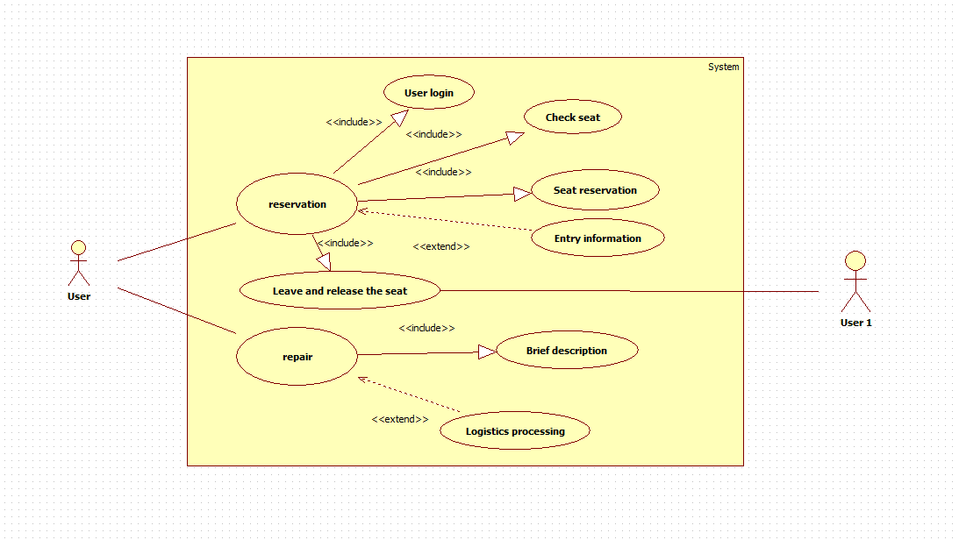

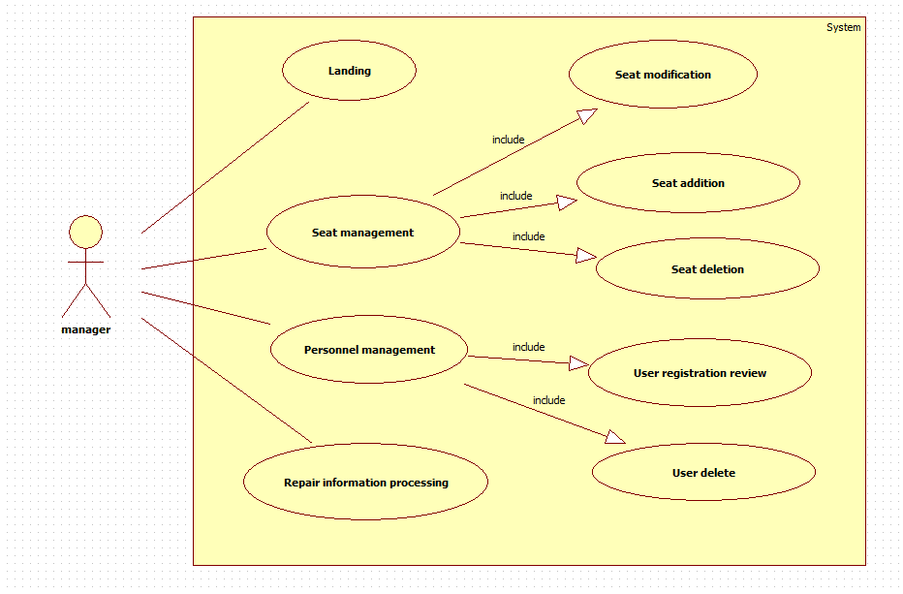

Traceability Matrix

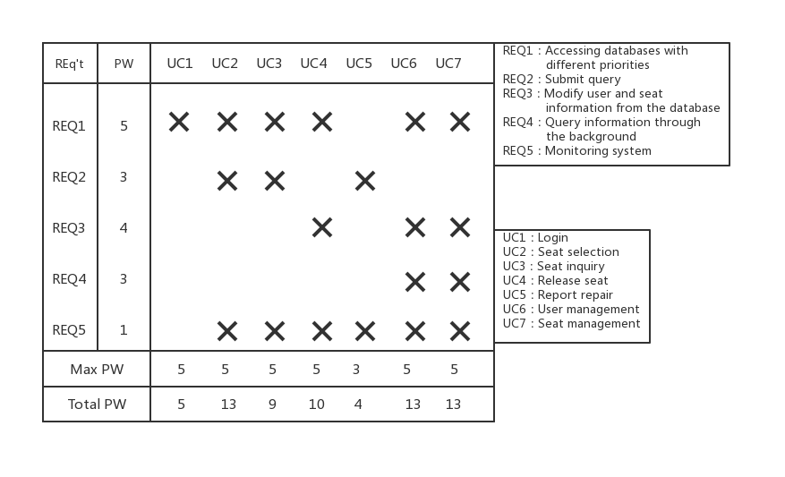

Fully-Dressed Description

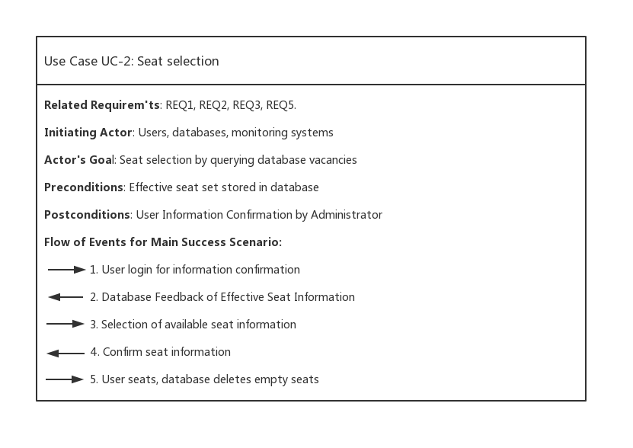

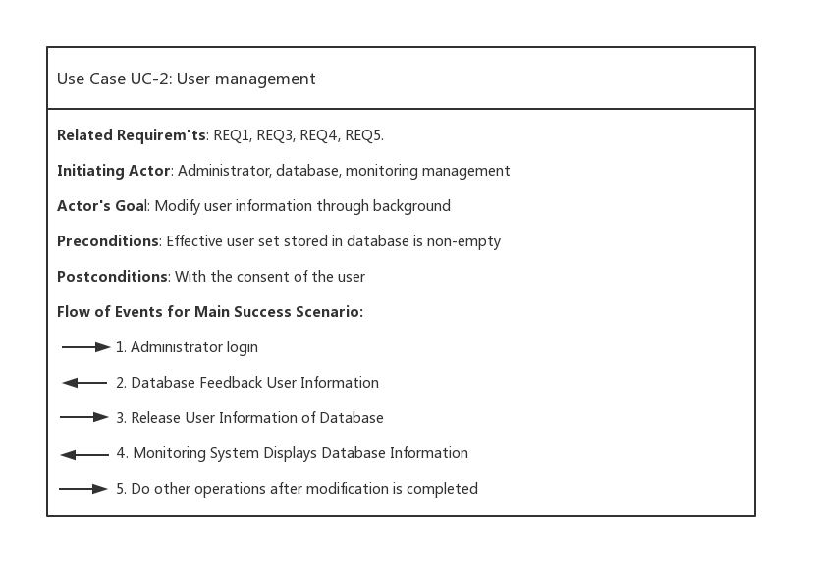

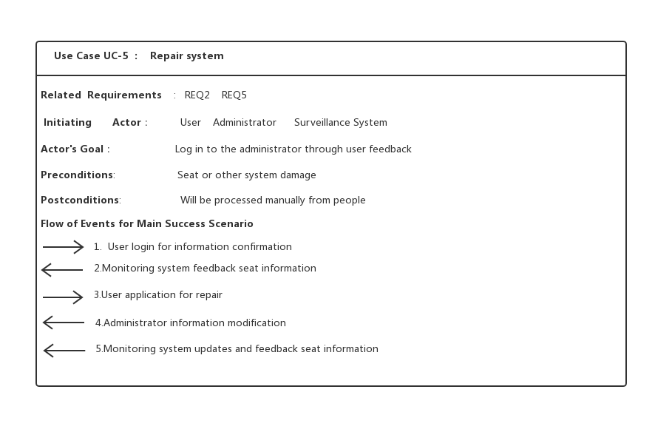

System Sequence Diagrams

UC1: Login

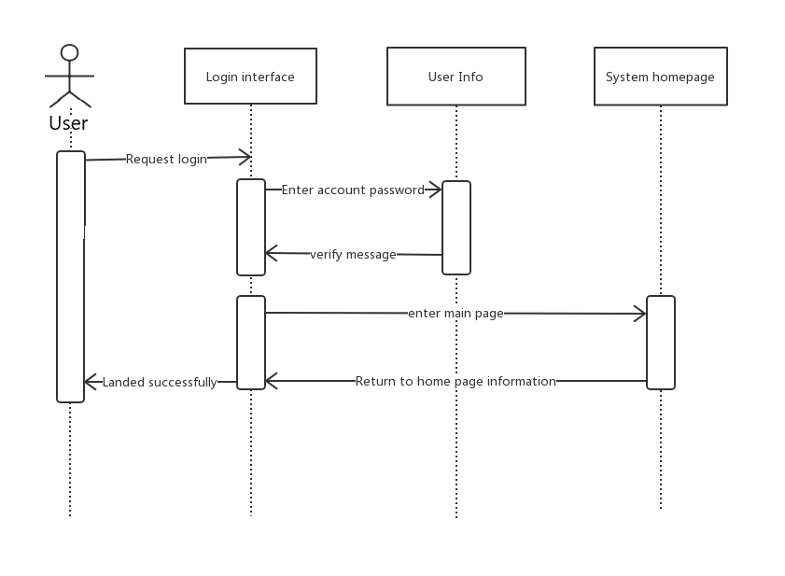

UC2: Seat Selection

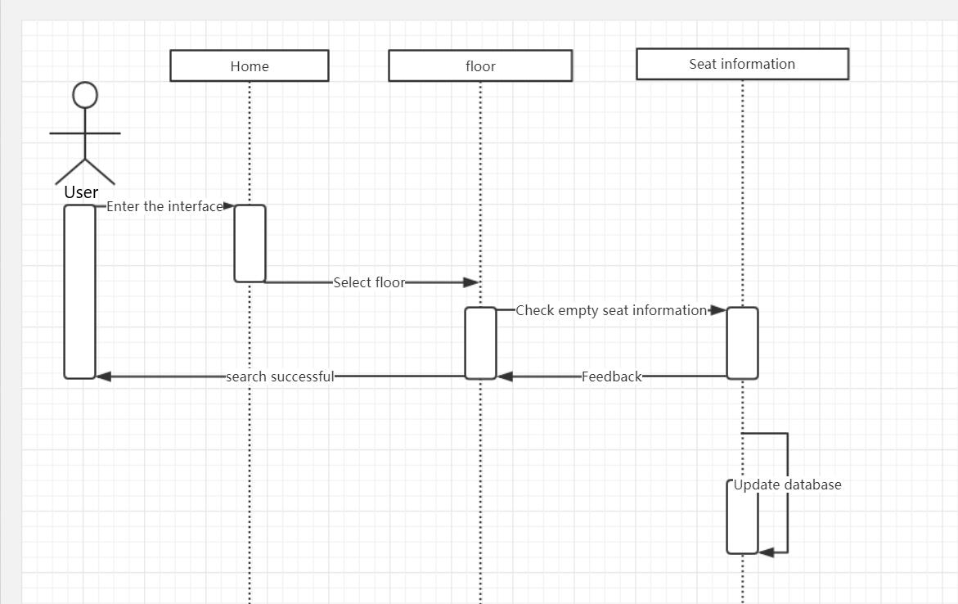

UC3: Seat Inquiry

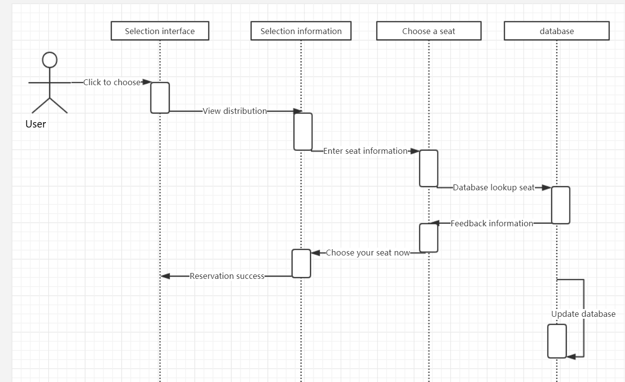

UC4: Release Seat

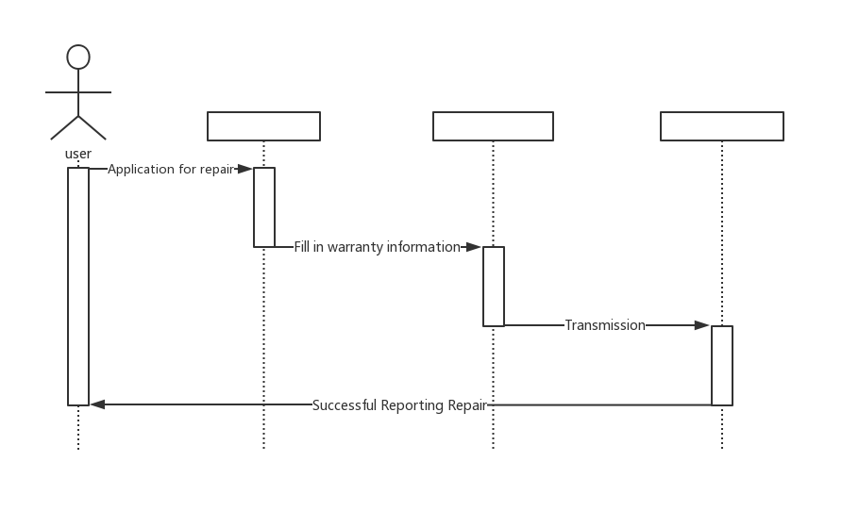

UC5: Report Repair

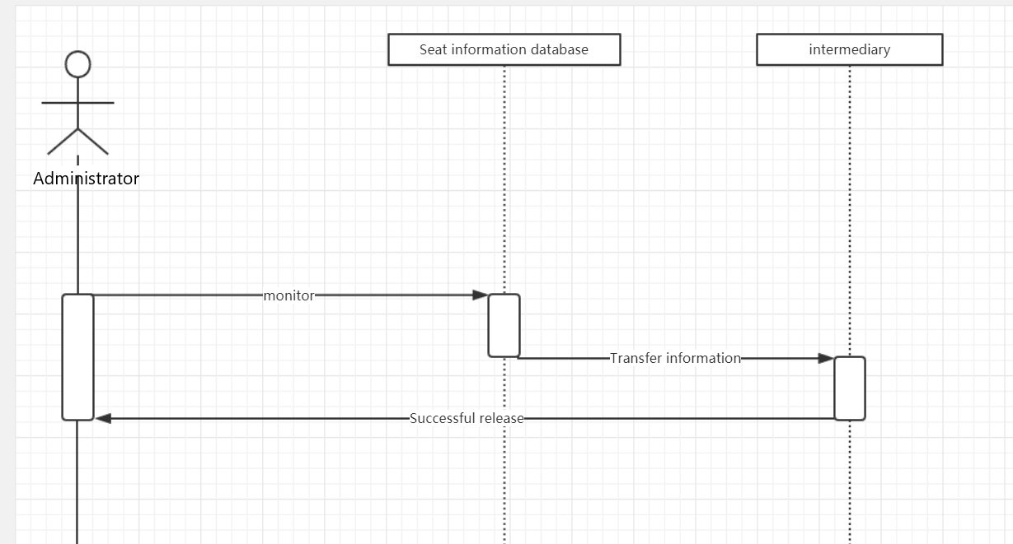

UC6: User Management

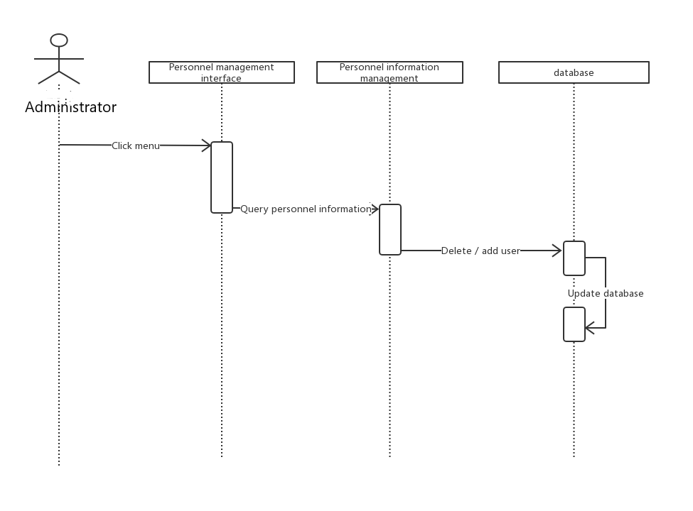

UC7: Seat Management

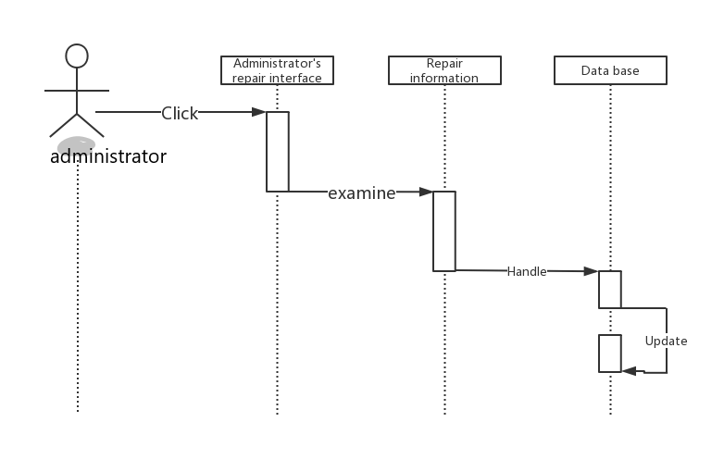

4.User Interface Specification

Preliminary Design

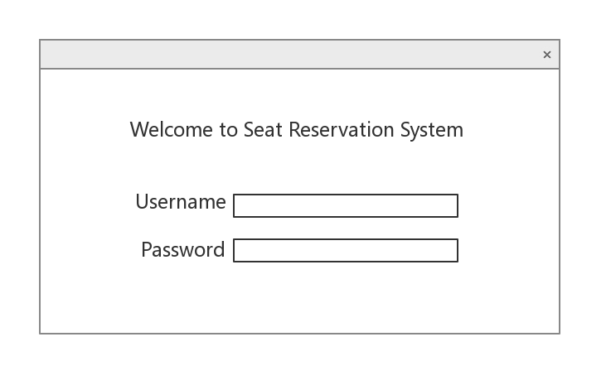

This is the "login page" of the library seating reservation system. After the student swipes the card into the library, he will go to the library seat reservation system machine to make a seat reservation. Students will see the "login page". Students need to enter the student's student number in the Username field, and the student enters the password in the password field (the password is usually the last six digits of the student's ID number). After the input is completed， click "ok" to proceed to the next step.

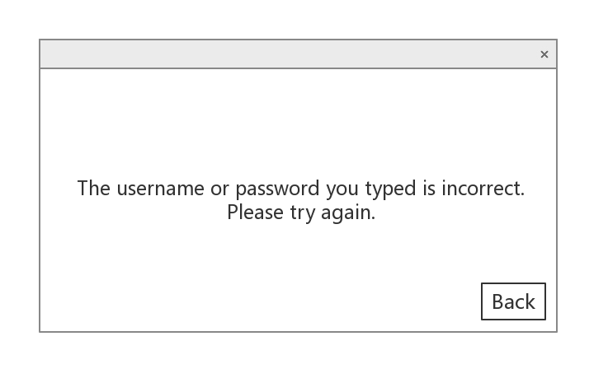

This is the "Logon Failure" interface. One of the situations where students enter their username and password in the "Login Page". The reason for this is that the student's username and password do not match, that is, the student's username or password input error. At this time, students will click on the "Back" button at the bottom right of the page to return to the previous "login page" and re-enter the student's username and password.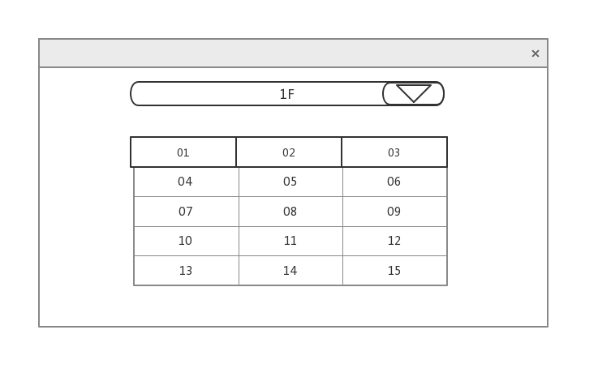This is the interface for "selecting a seat." After the student successfully logs in to the “Login Page”, he will automatically jump to the “Select Seat” page. On this page, students can click on the seating chart below to select the seat number they want. If the student does not want to choose a seat on the first floor, then click the inverted

OK

triangle button at the top right to select the floor. Each floor has a choice of seats to meet the requirements of most students. After the student has selected, click the “OK” button in the lower right corner to complete the entire process of booking a seat.

User Effort Estimation

a. Open the login interface;

b. Click on the username;

c. Enter the username;

d. Click on the password;

e. Enter the password;

f. Click OK to enter the seat selection interface;

g. Select a floor;

h. choose a seat;

i. Click OK to complete the reserved seat;

j. Exit the login interface.

Mouse clicks required for the task: 7

User interface navigation and document input 2 parts

URL

<https://github.com/library-seating-reservation-system>